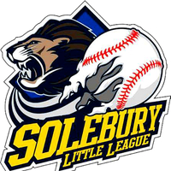

2026 Solebury Baseball & Softball League Sponsorship Order Form

Thank you for supporting our league! Please complete this form and email it to ddealmo@outlook.com.

Payment Options
- Check: Payable to Solebury Township Baseball & Softball League, PO Box 68, Carversville, PA 18913 (no charge)
- PayPal: PayPal.Me/soleburytwpbaseball ($10 fee applies)

Sponsorship Levels – (All levels include Social Media Shoutouts)

Team Sponsorship — $475 (Limited Supply)
Name to Appear on Shirt (Block Letters):
__________________________________________________________

Banner Sponsorship — $415
Name/Contact Info for Banner:
__________________________________________________________
__________________________________________________________
- Gold Level Sponsor (Combo Sponsorship One Team + One Banner) - $840

About You and Your Company
Your Name:__________________________________________________________
Company Name:__________________________________________________________
Address:__________________________________________________________
Phone Number:__________________________________________________________
Website:__________________________________________________________
Email Address:__________________________________________________________
Company Description:__________________________________________________________

